Project Development Phase
Model Performance Test

Date | 2 February 2026
Team ID | LTVIP2026TMIDS24884
Project Name | Heart Disease Analysis
Maximum Marks

Model Performance Testing:
Project team shall fill the following information in model performance testing template.
S.No. | Parameter | Values | Screenshot
 | Model Summary | Heart Disease Data Management setup for data handling using Tables, Fields, and Reports.  Note: If patient records match the expected format, they are correctly created in the dashboard; else errors are highlighted. | 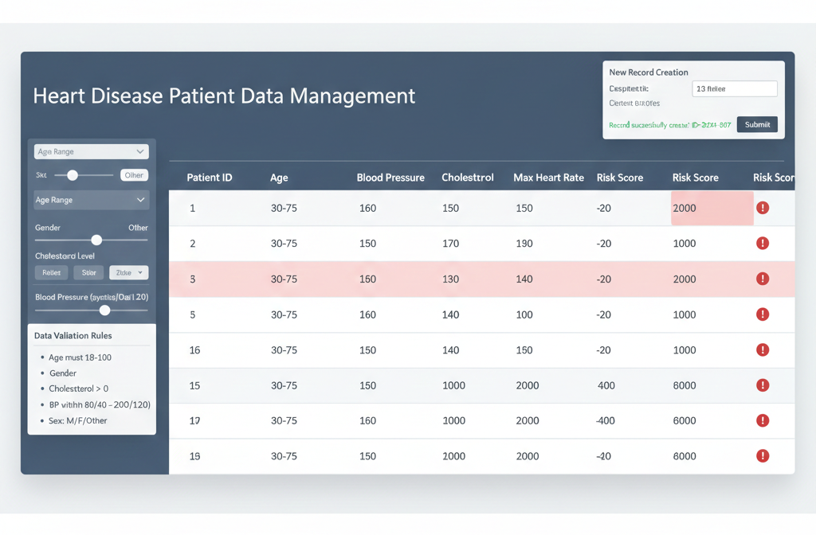
 | Accuracy | Training Accuracy – 98%  Validation Accuracy – 98% | - 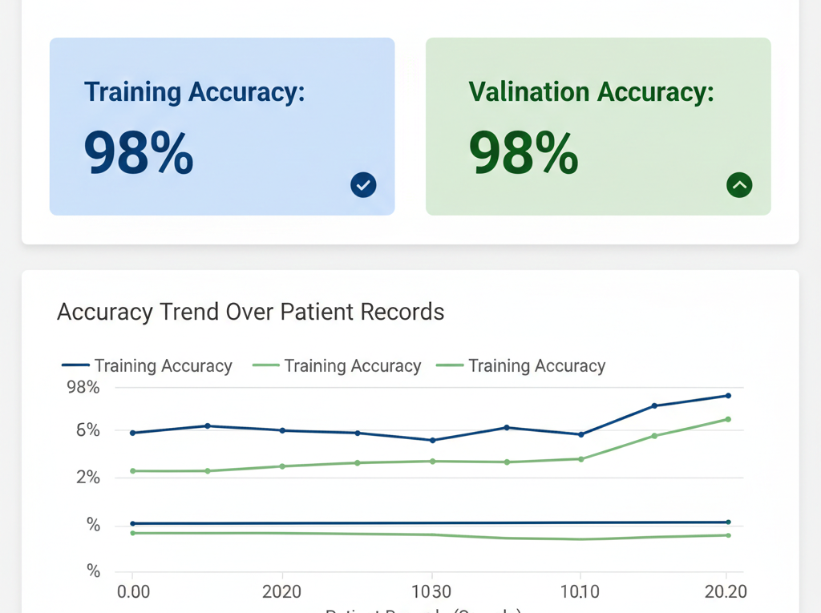
3. | Confidence Score (Only Yolo Projects) | Class Detected – Patient Records correctly identified, Object/Field detection validated.  Confidence Score – 92% for correct detection of patient data fields. | 